**1.Connect HBase**

use “Setting” -> “HBase Thrift Server” set server ip and port first

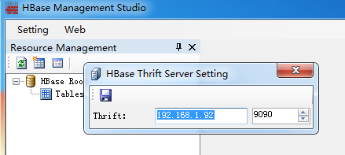

must start thrift1 server on HBase Master server first,use “hbase-daemon.sh start thrift”

**2.Click Refresh button Get all tables**

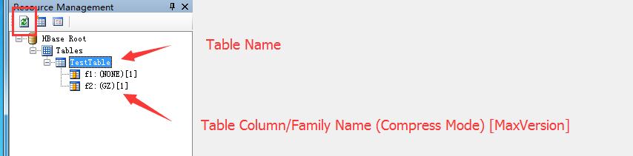

**3.New Table**

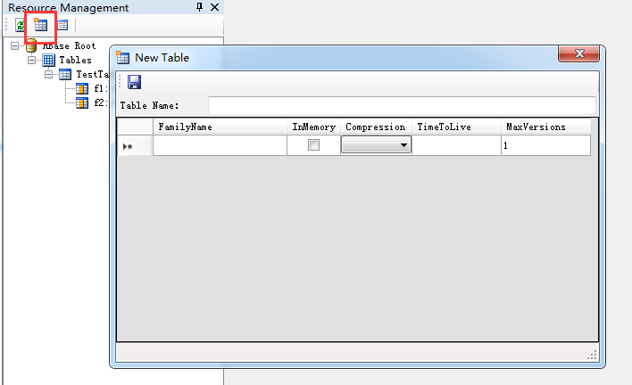

Compression can select “lzo” and “snappy”,but hbase and hdfs must support and set work,more information see : <http://hbase.apache.org/0.94/book/snappy.compression.html>

**4.Table Operations**

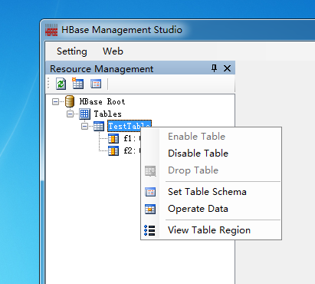

1. Enable Table:let table enable
2. Disable Table:let table no work
3. Drop Table:delete table,only can drop disabled table
4. Set Table Schema:setting table schema for operate data,see after 5.Set Table Schema Chapter
5. Operate Data:Query,Add Table Datas
6. View Table Regions:view table region distribution

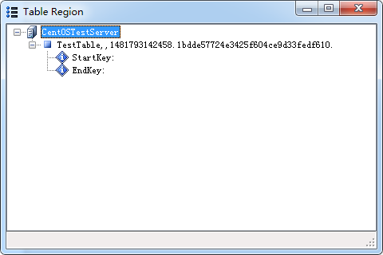

**5.Set Table Schema**

before operate table data,you must set table schema first,because HBase use byte array storage data,we don’t know really data type(also key type);

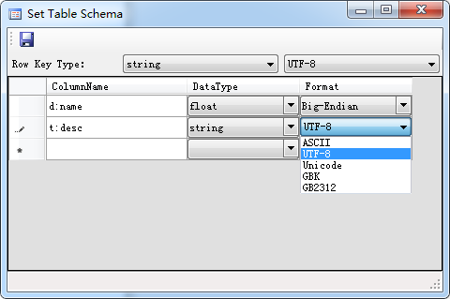

for decimal data,format is Big-Endian and Little-Endian;

for string,format is string Encoding;

also support OPC-UA format,using OPC-UA Variant Serialization datas:

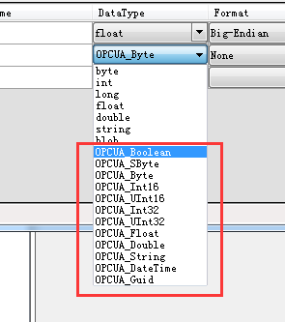

for more information,see: <https://github.com/opcfoundation>

**6.Operate Data**

now support table data Query and Scan.

Scan support three mode:

1. Full:Scan from start(first) record
2. Prifx:Scan with Key prifx filter
3. Range:Scan with Key Range (Start - End) filter